AFFILIATE AND INFORMATION MARKETING

Module
Steps In Building Information Marketing
Ways Of Creating Information Products
How To Build And Increase Traffic For The Promotion Of Information Marketing
How Traffic Can Be Made To Pay For Itself
How To Build Information Marketing Model
How To Create A Squeeze Page In Information Marketing
Ways Of Creating And Launching An Online Store
How To Set Up An Affiliate Market
Best Websites To Promote Information Products
Ways Of Becoming A Successful Affiliate Marketer

MODULE 1: STEPS IN BUILDING/STARTING INFORMATION MARKETING

1. Identify Your Niche:
Find your passion and expertise:
What are you knowledgeable and enthusiastic about? This will be the foundation of your information marketing business.
Research market demand:
Ensure there's a need for the information you plan to provide. Look for gaps in the market or areas where existing solutions are lacking.
Define your target audience:
Who are you trying to reach? Understanding their demographics, interests, and pain points is crucial.

2. Develop Valuable Content:
Create high-quality information products:
This could include eBooks, online courses, webinars, podcasts, or membership sites.
Focus on providing solutions:
Your content should address your audience's specific problems and offer actionable insights.
Offer different formats to cater to diverse learning styles:
Some people prefer reading, while others learn best through audio or video.

3. Build Your Platform:
Choose the right platform: Consider your target audience and the type of content you're creating. Options include a website, blog, social media, or an email list.
Create a professional online presence: Your website or profile should be visually appealing and easy to navigate.
Build an email list: Email marketing is a powerful tool for nurturing leads and promoting your products.

4. Promote Your Offerings:
Utilize content marketing:
Share your valuable content on your platform and other relevant online channels.
Engage with your audience:
Respond to comments, answer questions, and build a community around your brand.
Consider paid advertising:
Platforms like Facebook Ads or Google Ads can help you reach a wider audience.
Partner with other businesses:
Collaborate with complementary businesses to reach a broader audience.

5. Consistent Engagement and Optimization:
Regularly update your content: Keep your information fresh and relevant to your audience's needs.
Track your results: Monitor your website traffic, sales, and other key metrics to see what's working and what needs improvement.
Continuously refine your strategy: Based on your results, adjust your content, marketing efforts, and platform to maximize your impact.

By following these steps, you can build a successful information marketing business that provides value to your audience while achieving your own goals.

MODULE 3: HOW TO BUILD AND INCREASE TRAFFIC FOR THE PROMOTION OF INFORMATION MARKETING.
To build and increase traffic for the promotion of Information Marketing, various strategies can be used. Below are the different ways:

1. Search Engine Optimization (SEO)

Feature: Increases organic (free) traffic from search engines like Google.
• Optimizing content using keywords related to the information product.
• Writing valuable blog posts that rank on search engines.
• Building backlinks from other reputable websites.

Benefit: Long-term visibility and steady traffic without paying for ads.

2. Content Marketing

Feature: Uses valuable, informative content to attract and engage potential customers.
• Creating blog posts, videos, infographics, and podcasts.
• Addressing pain points and solving problems related to your niche.
• Sharing expert knowledge builds credibility.

Benefit: Establishes authority and drives traffic over time.

3. Social Media Marketing

Feature: Promotes content via platforms like Facebook, Instagram, Twitter, TikTok, LinkedIn.
• Sharing regular updates, tips, and promotions.
• Using hashtags and engaging with followers to increase visibility.
• Paid ads on social platforms to reach targeted audiences.

Benefit: Quick exposure and potential for viral growth.

4. Email Marketing

Feature: Uses emails to communicate directly with potential and existing customers.
• Collecting emails through opt-in forms or lead magnets (e.g. free eBooks, checklists).
• Sending newsletters and promotional content regularly.
• Personalizing messages for better engagement.

Benefit: Direct access to an interested audience with high conversion potential.

5. Affiliate Marketing

Feature: Leveraging other people to promote your product in exchange for a commission.
• Creating an affiliate program for your information product.
• Affiliates promote using their platforms and networks.
• You gain exposure without upfront ad costs.

Benefit: Expands reach and builds trust quickly through others’ audiences.

6. Paid Advertising (PPC)

Feature: Pays to display your marketing content on search engines and social media.
• Google Ads, Facebook Ads, Instagram Ads, YouTube Ads.
• Allows targeted audience selection by location, interests, behavior, etc.
• Use of compelling copy and visuals to get clicks.

Benefit: Fast traffic generation and scalable promotions.

7. Influencer Marketing
Feature: Collaborating with influencers to promote your product to their audience.
• Influencers review or use your information product.
• Can be done through shoutouts, videos, or testimonials.
• Often more effective when influencer matches your target niche.

Benefit: Builds credibility fast and reaches a loyal follower base.

8. Online Forums and Communities

Feature: Participating in niche-specific communities to share value and promote.
• Reddit, Quora, Facebook Groups, and niche forums.
• Answering questions and sharing expertise.
• Including links to your content when relevant.

Benefit: Builds trust and attracts a highly targeted audience.

Conclusion:
To successfully promote Information Marketing and drive traffic, a combination of organic and paid methods should be used. Each method has its own features, and when used strategically, they can help build a loyal audience and increase conversions.

MODULE 4: HOW TRAFFIC CAN BE MADE TO PAY FOR ITSELF

What Does It Mean?
When you bring people (called traffic) to your website or page by spending money, you want to make enough money from them to cover that cost or even make profit.

Simple Flow:
Pay for Ads → People Visit → Some Buy → You Make Money → Reinvest

1. Recommend Products (Affiliate Links)
- Share useful links or products.
- When people buy through your link, you earn money.

Example:
- Spend $10 on ads.
- Someone buys through your link.
- You earn $15.
- You made back your $10 and gained $5.

2. Offer a Small Product First (Tripwire)
- Sell a cheap item (like $5 or $10).
- Helps you recover your ad cost fast.
Example:
- 10 people visit, 2 buy your $10 ebook.
- You earn $20.
- If your ad cost was $15, you made $5 profit.

3. Collect Emails for Future Sales
- Offer something free (like a guide) for their email.
- Use the email to send more product links later.
Example:
- Spend $50, collect 100 emails.
- Later, 5 people buy a $20 product = $100.
- You made back double.

4. Sell More After First Purchase (Upsell)
- After someone buys, offer them a bigger product.
Example:
- First sale = $10.
- Upsell = $40 coaching.
- Some buy both. You earn more from one person.

5. Retargeting Visitors
- Show ads again to those who visited but didn’t buy.
- Cheaper and more likely to buy the second time.
Example:
- First ad: $1, no sale.
- Second ad: $1, they buy a $25 product.
- You made $23 profit.

Summary

Strategy | How It Pays You Back
Recommend Products | Earn commission when they buy
Small Product Offer | Covers ad cost quickly
Email Collection | Earn later through email sales
Upsell More Products | Get more from each buyer
Retarget Visitors | Get second chance to make money

VISUAL REPRESENTATION

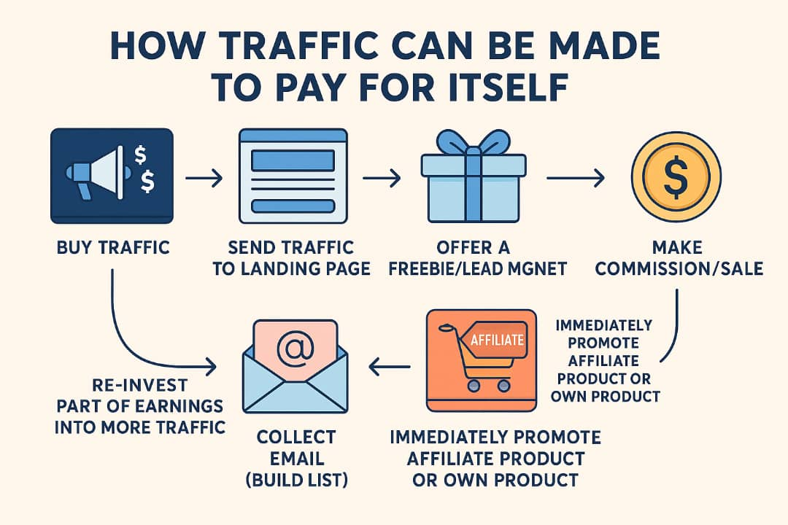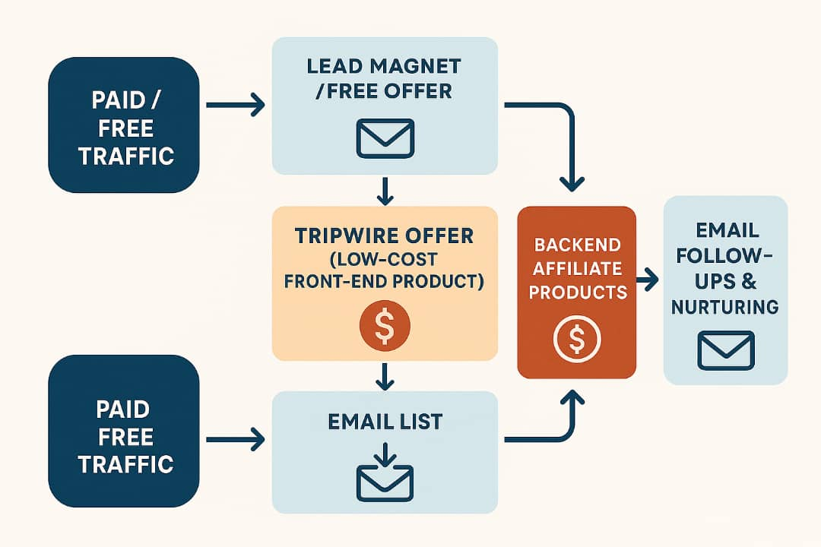
MODULE 5: BUILDING AN INFORMATION MARKETING MODEL: A STRATEGIC GUIDE

Information marketing is all about packaging and delivering valuable knowledge to a target audience, usually in exchange for money or loyalty. It’s the backbone of online courses, eBooks, podcasts, coaching programs, and more. Here's how to build a successful model with diverse strategies:

Step 1: Pick Your Topic (Niche) and Audience
Before anything else, ask yourself:
• What do I know well? Could be cooking, parenting, fitness, finance — anything.
• Who needs this info? Young moms? Busy professionals? Students?
Example: You love fitness and want to help beginners get in shape at home.

Step 2: Create a “Value Ladder”
This means offering different levels of products to suit different budgets:
• Free stuff: Tips on social media, YouTube videos
• Small paid products: eBooks or $10 mini-guides
• Medium products: Online courses or $50 video packages
• Premium: $500 coaching or mentorship

Step 3: Choose a Strategy That Fits You
Here are different ways to sell your information:
Strategy | How It Works | Who Should Use It
Teach & Educate | Create blogs, videos, podcasts | People who like helping & sharing
Affiliate Marketing | Promote others’ products, earn commissions | Social media lovers, influencers
Course Launching | Build hype before selling a new product | Content creators & experts
Subscription Models | Monthly membership for access | Coaches, community builders
Personal Consulting | One-on-one advice or help | Professionals & experts

Step 4: Set Up the Tools
You’ll need some tools to make things work:
• Use Canva to design your content
• Use Teachable or Kajabi to sell courses
• Use Mailchimp to send emails
• Use Instagram, TikTok or Facebook to promote

Step 5: Start Making Money
Your options:
• Sell digital products like eBooks or courses
• Offer paid coaching
• Run workshops or webinars
• Charge for access to private content or groups

Step 6: Improve Over Time
Look at your results:
• Which posts got the most likes or sales?
• Where did people drop off in your sales funnel?
• Ask for feedback — then tweak and improve

CONCLUSION
In Conclusion Building an information marketing model requires a clear niche, valuable content, and the right strategy for growth and monetization.

MODULE 7: WAYS OF CREATING AND LAUNCHING ONLINE STORE
Planning and Preparation
1. Define your niche: Determine the products or services you'll sell.
2. Conduct market research: Understand your target audience and competitors.
3. Create a business plan: Outline your goals, strategies, and financial projections.
4. Choose an e-commerce platform: Select a platform that suits your needs, such as Shopify, WooCommerce, or BigCommerce.

Setting Up the Online Store
1. Register a domain name: Choose a unique and memorable domain name.
2. Set up hosting: Choose a reliable web hosting service.
3. Install necessary plugins and apps: Enhance your store's functionality with plugins and apps.
4. Customize your store's design: Create a visually appealing and user-friendly design.

Adding Products and Content
1. Add products: Create product listings with detailed descriptions, images, and pricing.
2. Create high-quality content: Develop a content strategy that showcases your products and brand.
3. Optimize for SEO: Ensure your store is search engine-friendly.

Launching the Online Store
1. Test and iterate: Test your store's functionality and make necessary adjustments.
2. Launch your store: Make your store live and available to customers.
3. Promote your store: Develop a marketing strategy to attract customers.

Post-Launch Activities
1. Monitor and analyze performance: Track your store's performance and make data-driven decisions.
2. Improve and optimize: Continuously improve and optimize your store's design, functionality, and content.
3. Provide excellent customer service: Ensure customer satisfaction and build loyalty.
Some popular e-commerce platforms and tools include:
- Shopify
- WooCommerce
- BigCommerce
- Magento
- Etsy (for handmade or vintage items)

Module 8: How to Set Up an Affiliate Market

What is affiliate marketing?
Basically, it’s like having other people (affiliates) sell your goods or services online. They get paid a commission only when they bring you a sale or a lead. You win, they win. Simple!

Here’s how you set it up (step by step):

1. Pick what you want to sell
Start with 1–2 digital products (like your eBook or course).
2. Decide how to pay affiliates
- Pay-Per-Sale (most common): "You sell my $50 course? I’ll give you $20!"
- Pay-Per-Lead: "Get someone to sign up for my newsletter? Here’s $5!"
→ Tip: For digital products, offer 30–50% commission. It’s attractive!

3. Choose a tool to manage it
- For beginners: Use Refersion or Tapfiliate (cheap + easy).
- For bigger reach: Try ShareASale or ClickBank (but they take a cut).

4. Write clear rules
Cover things like:
- How long your "tracking cookie" lasts (30–90 days is normal).
- How/when affiliates get paid (e.g., "$50 minimum via PayPal").
- What’s NOT allowed (spamming, fake ads, etc.).

5. Find your affiliates!
- Add a page on your site: "Join My Affiliate Program."
- Reach out to bloggers, YouTubers, or Instagrammers in your niche.
- List on affiliate networks (they’ll bring people to you).

6. Give them "marketing kits"
Pre-made tools like:
- Banners
- Email templates
- Social media posts
- Their unique referral link (so you know who brought the sale).

7. Track & tweak
Check your tool’s dashboard:
- Who’s bringing sales?
- What’s converting?
- Example: If "Sarah" brings 60% of your sales, maybe give her a bonus!

8. Pay on time
Nobody likes late payments. Automate it if you can!

Key to Success?
- Be transparent: Show affiliates their stats in real-time.
- Talk to them: Send updates, tips, or even a "thanks!"
- Start small: 5–10 great affiliates > 100 inactive ones.

Affiliate marketing can become 20–30% of your revenue. It’s like having a sales team that only gets paid when you get paid!

MODULE 9: Best websites and platforms to promote and sell information products
1. Gumroad
Great for selling eBooks, courses, templates, and memberships with ease.

2. Teachable / Thinkific
Perfect for hosting and selling online courses with built-in marketing tools.

3. Kajabi
All-in-one platform for selling digital products, email marketing, and landing pages.

4. Udemy
Ideal for reaching a large audience if you're offering educational content.

5. Etsy (Digital Downloads section)
Good for selling templates, printables, planners, and digital art.

6. Amazon Kindle Direct Publishing (KDP)
Best for publishing and promoting eBooks.

7. Payhip
Simple platform to sell digital downloads, memberships, and courses.

8. Podia
Similar to Teachable, with added features like webinars and digital product bundles.

9. Coursera / Skillshare
If you want to earn from high-quality courses and reach a professional audience.

10. Your Own Website + Email Marketing
Build your brand and promote via a website using tools like WordPress + ConvertKit or Mailchimp.

MODULE 10: WAYS OF BECOMING A SUCCESSFUL AFFILIATE MARKETER
To become a successful affiliate marketer, you need more than just joining affiliate programs — you need strategy, consistency, and a deep understanding of your audience. Below are key ways to become successful in affiliate and information marketing:

1. Choose the Right Niche
• Explanation: Focus on a niche you’re passionate about and that has a demand for products. For example, niches like health, fitness, finance, relationships, and digital tools have large, engaged audiences.
• Why important: It’s easier to create consistent, high-quality content and build trust when you’re knowledgeable and interested in the topic.

2. Select High-Quality Affiliate Programs
• Explanation: Partner with reputable companies that offer competitive commissions and reliable tracking.
• Example: Amazon Associates, ClickBank, ShareASale, JVZoo, or private company programs like Bluehost or Grammarly.
• Why important: Promoting quality products increases your credibility and boosts conversions.

3. Build a Platform (Website, Blog, or YouTube Channel)
• Explanation: Create a digital presence where you can share content and embed your affiliate links.
• Why important: Your platform becomes your personal brand and trust-building tool. It also gives you a space to educate, review, and promote.

4. Create High-Value Content
• Explanation: Write blog posts, make videos, create tutorials, and reviews that genuinely help people solve problems.
• Why important: Good content builds trust, increases traffic, and motivates people to click and buy through your affiliate links.

5. Build an Email List
• Explanation: Offer a free resource (like a PDF guide or mini-course) in exchange for email addresses.
• Why important: Email marketing allows you to follow up with potential buyers, nurture relationships, and promote products directly.

6. Drive Targeted Traffic
• Explanation: Use SEO (search engine optimization), social media, paid ads, or YouTube to bring traffic to your content.
• Why important: The more targeted visitors you get, the higher your chance of making sales.

7. Use Honest and Transparent Promotion
• Explanation: Always disclose affiliate links and focus on providing real value instead of just selling.
• Why important: Builds credibility and long-term trust with your audience.

8. Analyze and Optimize Performance
• Explanation: Use tools like Google Analytics, affiliate dashboards, or heatmaps to monitor what’s working and what’s not.
• Why important: Helps you double down on effective strategies and improve weak areas.

9. Learn Copywriting and Persuasion Skills
• Explanation: Learn how to write compelling headlines, product reviews, and calls to action that get clicks.
• Why important: The way you present a product can make a big difference in conversion rates.

10. Stay Consistent and Keep Learning
• Explanation: The online marketing world is always evolving — algorithms, consumer behavior, and tools change.
• Why important: Continuous learning and patience help you adapt and grow long-term success.

